Global Winds (pgs. 404-407) & Coriolis Effect (pg.403)
Name __________________________________ Class Color _____________ Handout #_____

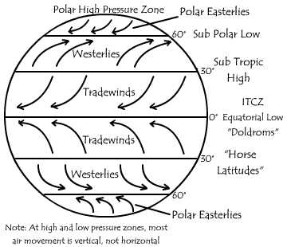
Coriolis Effect: page 403
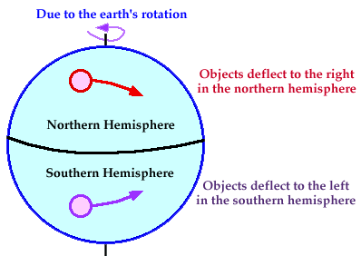

- Wind is created by pressure
- The greater the pressure, the faster the wind moves.
- Warmer, less-dense air rises.
- Colder, more-dense air sinks.
- Cold, sinking air creates areas of high pressure.
- Warm, rising air creates areas of Low pressure.
- Pressure Belts are found at- 60 degrees S (low pressure), 30 degrees S (high pressure), degrees (low) 30 degrees N (high), 60 degrees N (low)
Types of winds:
- Trade winds are found in _________________________________ and blow from
_____ degrees to the ______________________________.

- The Doldrums meet in an area of _________ pressure around the equator.
- The Horse Latitudes are found at about ____degrees north and south latitude where sinking air creates an area of _______ pressure. The winds are weak.
- The Westerlies are wind belts are found in both the Northern and Southern Hemispheres between ____ degrees and ____ degrees latitude. The Westerlies flow toward the poles in the opposite direction of the trade winds.
- The Polar Easterlies are wind belt that extend from the _______ __to
_____ degrees latitude in both hemispheres.

- Jet Streams are narrow belts of ________- _________winds that blow in the upper
Troposphere and lower _______________________.

- Local Winds are influenced by the ___________________of an area.

